**Nexus Installation and configuration guide**

|  |  |  |  |
| --- | --- | --- | --- |
| **Document Name** | **Version** | **Prepared by** | **Reviewed by** |
| Nexus Installation and configuration guide | v.01 | Tarunendra Tripathi | Sumit Malhotra |
|  |  |  |  |

Contents

Introduction 1

Reference URL 1

Download Installation file 2

Install nexus 2

Configuration of nexus 2

Configuration Nexus Port 3

Workaround/Issue debugging 5

Jenkins settings 6

# Introduction

This document contains the installation and configuration of Nexus on RHEL environment.

Reference URL

<https://devopscube.com/how-to-install-latest-sonatype-nexus-3-on-linux/>

<https://help.sonatype.com/repomanager2/installing-and-running/configuring-nexus-repository-manager-as-a-service>

# Download Installation file

Download below tar file

Nexus-3.28.1-01-unix.tar.gz

# Install nexus

Use below command to untar the tar file.

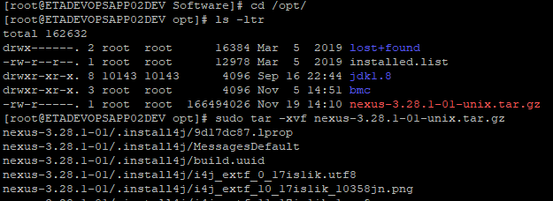

# Configuration of nexus

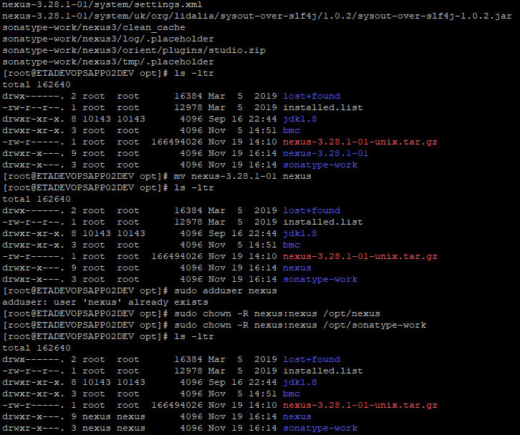









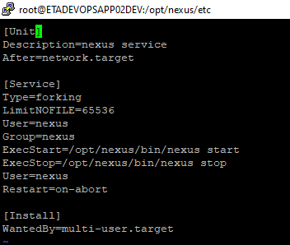

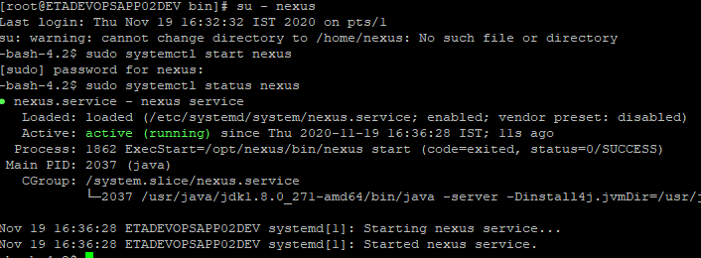

# Configuration Nexus Port

NEXUS Configuration steps***************************************************************

<https://www.fosslinux.com/27838/installing-sonatype-nexus-repository-oss-on-centos-7.htm>

To install nexus:

./nexus run

/opt/nexus/etc

nexus-default.properties

change the port and hots ip

host:10.191.159.49

post:8082

Change the port over hare and hots

systemctl daemon-reload

Enable service on system boot.

systemctl enable nexus.service

Start service.

systemctl start nexus.service

Monitor the log file.

tail -f /opt/nexusdata/nexus3/log/nexus.log

UAT:-

Uat nexus log path - /opt/sonatype-work/nexus3/log

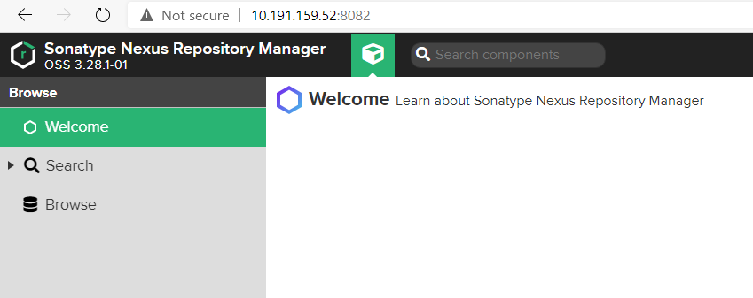

==============================

# Workaround/Issue debugging

1) if error coming during password change or db space issue

Ans- change the db space size in below path.

/opt/nexus/bin/nexus.vmoptions



-Dstorage.diskCache.diskFreeSpaceLimit=4096

Create new repo:-

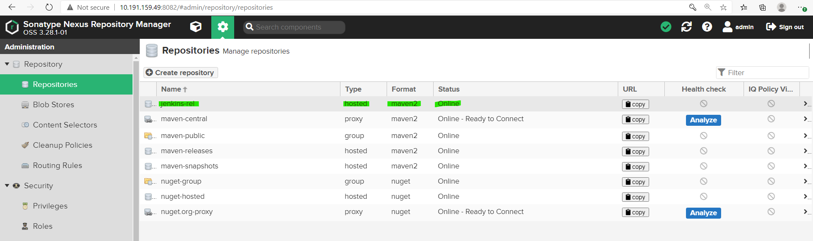

**Update verion:- keep verion as number only no need to add any text.**

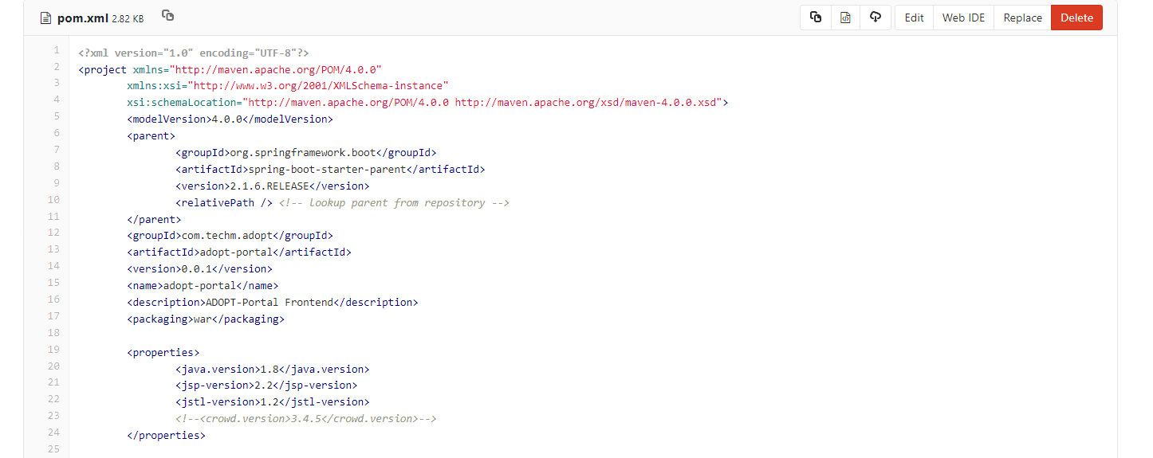

# Jenkins settings

